VIT-AP University

SCOPE

DBMS Lab – L21+L22 Slot

**Task-6 (Joins)**

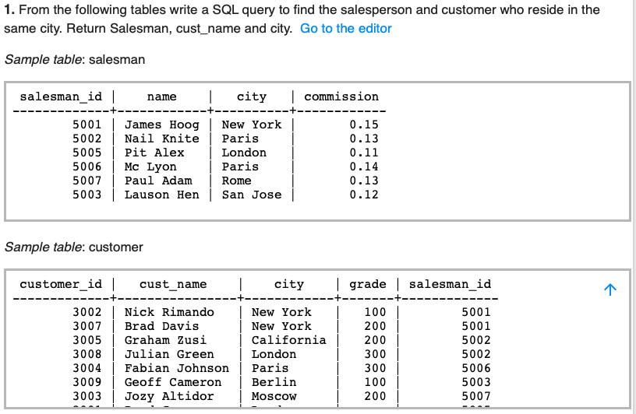

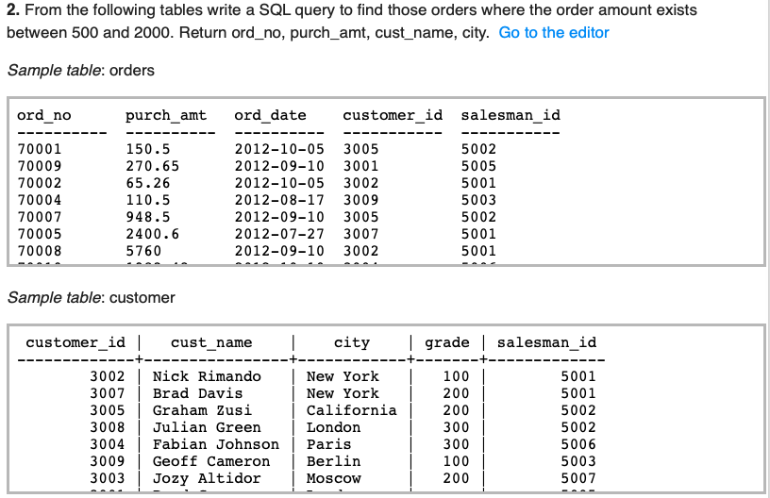

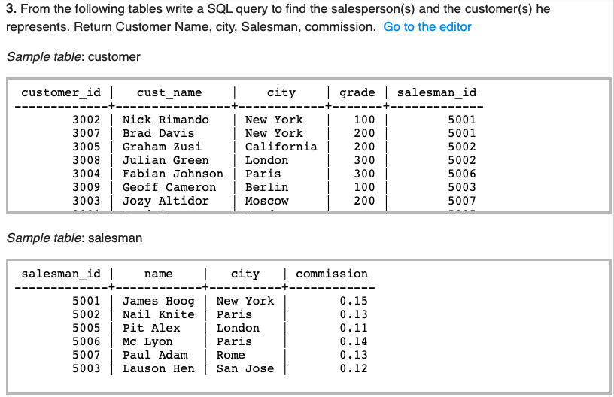

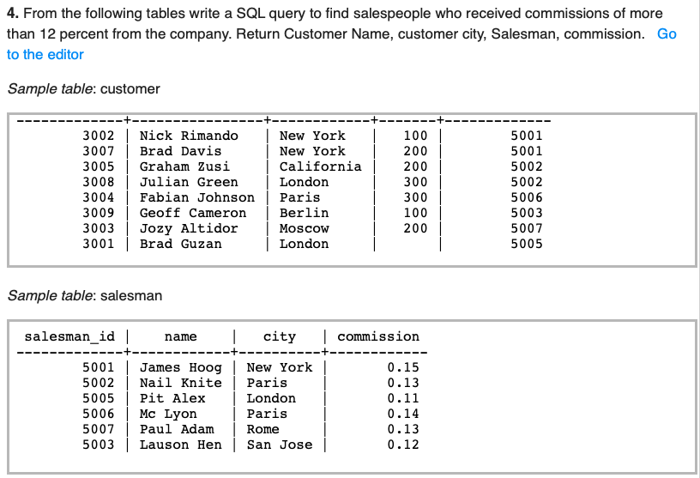

5. From the following tables write a SQL query to find the names of departments where more than two employees are employed. Return dpt_name.

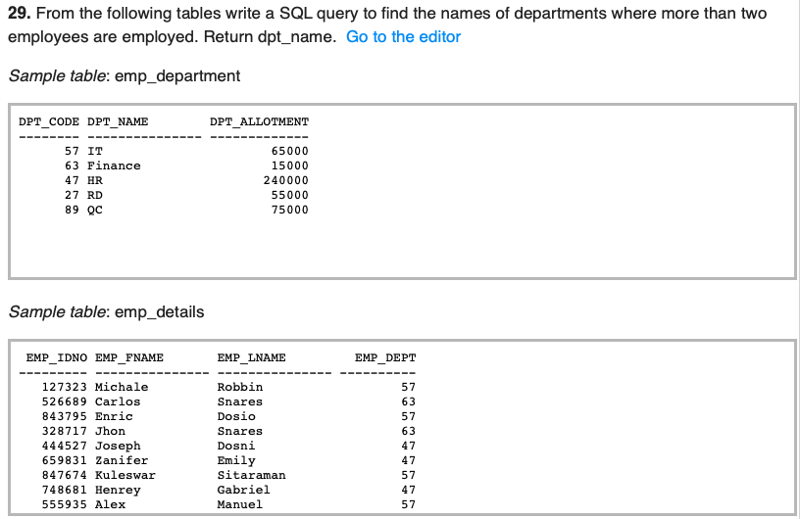

6. From the following tables write a SQL query to display the first and last names of each employee, as well as the department name and sanction amount.

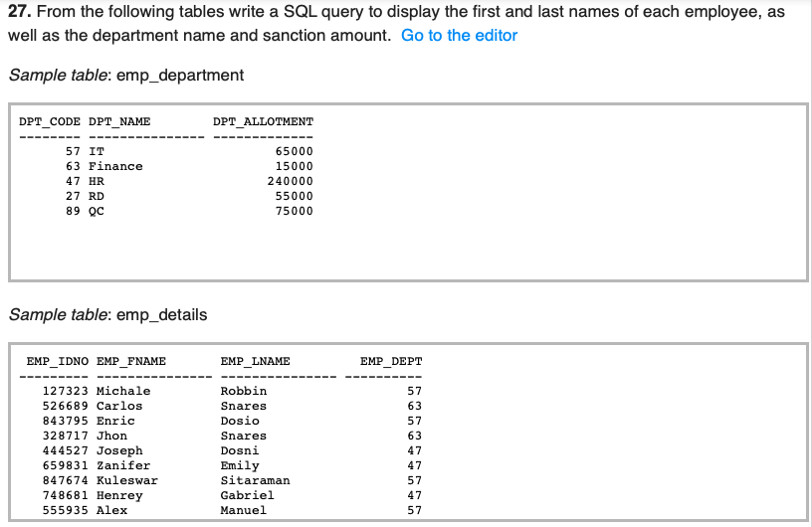

7. From the following tables write a SQL query to calculate the average price of items of each company. Return average value and company name.

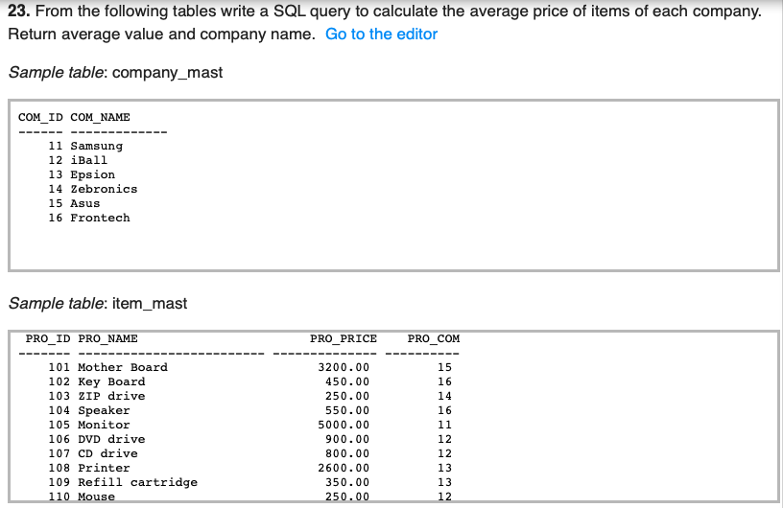

8. Write a SQL statement to create a Cartesian product between salesperson and customer, i.e. each salesperson will appear for every customer and vice versa for those salesmen who belong to a city and customers who require a grade.

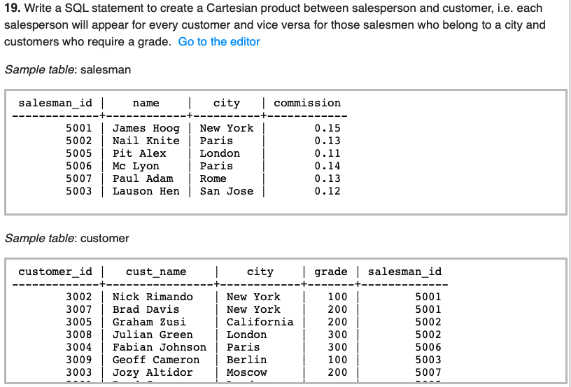

9. Write a SQL statement to make a list for the salesmen who either work for one or more customers or yet to join any of the customer. The customer may have placed, either one or more orders on or above order amount 2000 and must have a grade, or he may not have placed any order to the associated supplier.

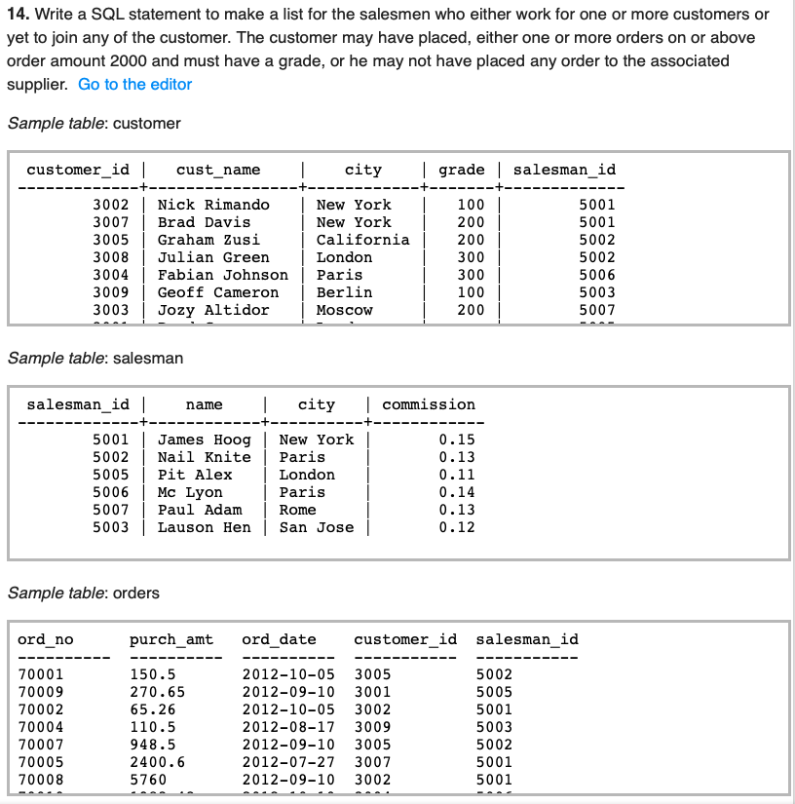

10. SQL statement to generate a report with customer name, city, order number, order date, order amount, salesperson name, and commission to determine if any of the existing customers have not placed orders or if they have placed orders through their salesman or by themselves.

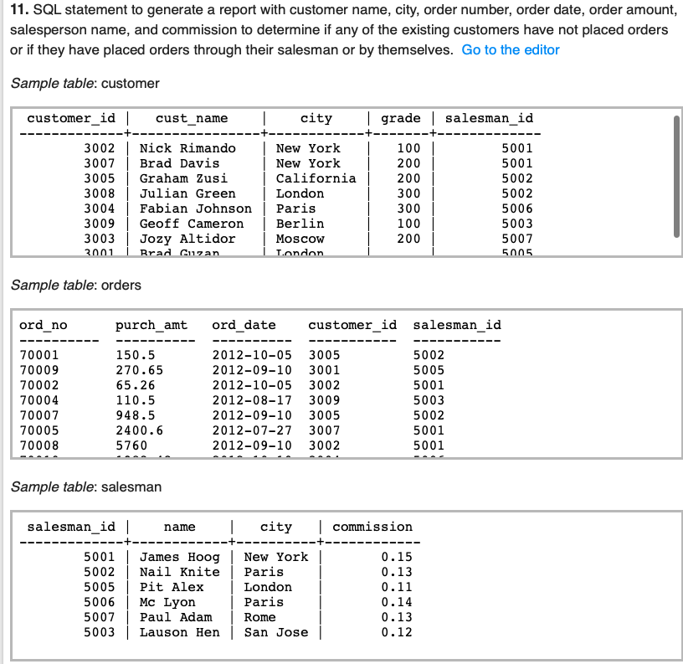

11. From the following tables write a SQL query to display the customer name, customer city, grade, salesman, salesman city. The results should be sorted by ascending customer_id.

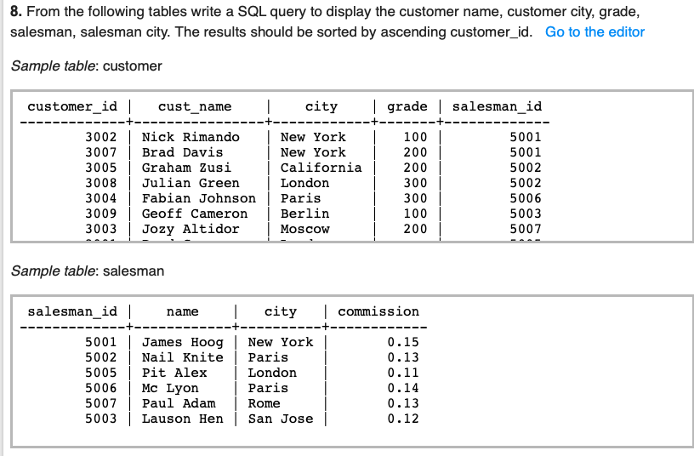

12. Write a SQL statement to join the tables salesman, customer and orders so that the same column of each table appears once and only the relational rows are returned.

